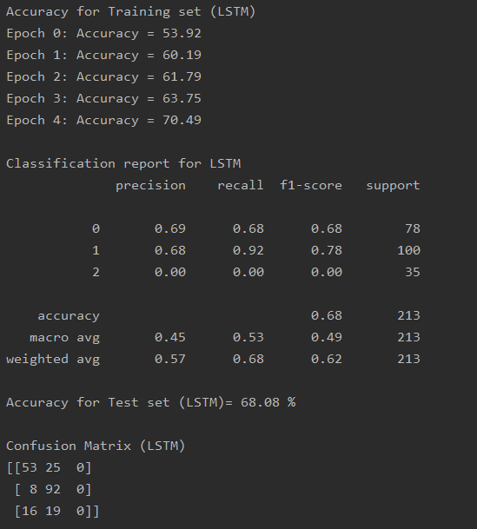

Accuracy for Training set (LSTM)

Epoch 0: Accuracy = 53.92

Epoch 1: Accuracy = 60.19

Epoch 2: Accuracy = 61.79

Epoch 3: Accuracy = 63.75

Epoch 4: Accuracy = 70.49

Classification report for LSTM

precision recall f1-score support

0 0.69 0.68 0.68 78

1 0.68 0.92 0.78 100

2 0.00 0.00 0.00 35

accuracy 0.68 213

macro avg 0.45 0.53 0.49 213

weighted avg 0.57 0.68 0.62 213

Accuracy for Test set (LSTM)= 68.08 %

Confusion Matrix (LSTM)

[[53 25 0]

[ 8 92 0]

[16 19 0]]